Application Form
Start your Blooming Future!

Green Angels is an exciting training opportunity with an environmental focus, giving you the chance to learn new skills, change your future prospects and make a difference in your community.
Our FREE environmental courses cover subjects such as wildlife conservation, landscaping, environmental education, horticulture and more. Training programmes usually last around six weeks, with regular sessions that combine learning with hands-on experience.
If you would like to find out more, or to apply for a course, please complete the form below and return to:
greenangels@thelandtrust.org.uk OR Green Angels, the Land Trust, 7 Birchwood One, Dewhurst Road, Birchwood, WA3 7GB
Green Angels training is open to everyone over the age of 18
Name:

Address:

Postcode:
Tel:
Mob:
Email:
☐ | Please tick box - I give my consent for the Land Trust to hold my information so that I can be kept informed of Green Angels training courses, events and activities.
☐ | Please tick box - I give my consent for the Land Trust to hold my information so that I can receive newsletters and publicity about the Green Angels project.
Please choose how you would like us to contact you:
EMAIL ☐ |  | POST ☐ | TELEPHONE ☐
(Place an X in the relevant boxes)
Which areas of training are you interested in? |  |  | How did you hear about Green Angels?
☐Wildlife Identification |  |  | This information helps us to target our publicity/promotion effectively
☐Environmental Education |  |  | ☐Website
☐Outdoor Wellbeing |  |  | ☐Social media
☐Bushcraft & Survival Skills  ☐Hard Landscaping  ☐Countryside Management |  |  | ☐Press  ☐Word of mouth  ☐Job Centre
What is your employment status? |  |  | 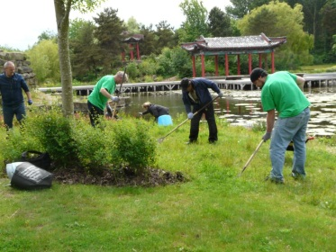  ☐ Other
This information is used for statistical purposes and to plan course schedules:
☐ Employed full-time |  | ☐ Employed part-time
☐ Unemployed |  | ☐ Retired
☐ Student |  | ☐ Other
Would you require transport reach Hassall Green Nature Reserve?
☐ Yes | ☐ No

Withdrawing consent:
Consent can be withdrawn at any time by contacting the Land Trust:
Email: enquiries@thelandtrust.org.uk; Tel. 01925 852005
By Post: The Land Trust, 7, Birchwood One, Dewhurst Road, Warrington WA3 7GB
For queries, please contact:
Josie Muncaster, Green Angels Project Officer
greenangels@thelandtrust.org.uk
01925 852005 or 07920 139209
For an electronic version of this form, visit https://thelandtrust.org.uk/greenangels/hassallgreen

