**Butterfly walk at Brook Park wanxxxxxxxxxxxxx**

**Sunday 17 June 2018 at 2pm**

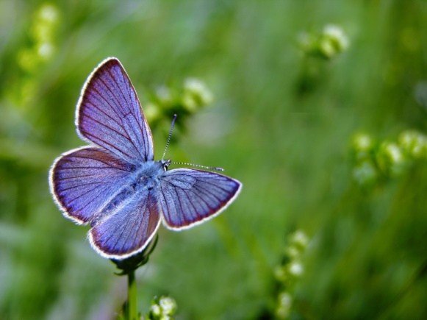

A guided walk looking for butterflies to be found at Brook Park in Shirebrook

Everyone welcome. It’s FREE no need to book

Meet at Roundabout by Entrance to staff car park, Sports Direct, off Weighbridge Road, Brook Park, Shirebrook NG20 8RY. Parking by kind permission of Sports Direct

For more information contact Marion Farrell at Groundwork 07801 122494

