Green Angels
needs YOU!

Green Angels is an exciting training opportunity with an environmental focus, giving you the chance to learn new skills, change your future prospects and make a difference in your community. Our FREE courses cover subjects such as countryside management, landscaping, environmental education, horticulture and more. Training programmes usually last around six weeks, with regular sessions that combine learning with hands-on experience.

New courses are starting soon in the Warrington area

If you would like to find out more, or apply for a course, please complete the form below

Name:

Address:

Postcode:
Tel/Mob:

Email:

(Place an X in the relevant boxes)

Which areas of training are you interested in? How did you hear about Green Angels?
☐Countryside management ☐Website
☐Hard landscaping ☐Job Centre
☐Environmental education ☐Social media
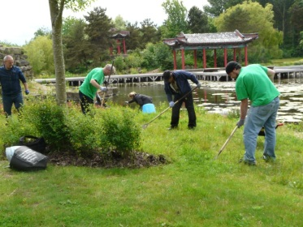
☐Horticulture ☐Press
☐Word of mouth
What is your employment status? ☐Other
☐ Employed full-time
☐ Employed part-time
☐ Unemployed
☐ Retired
☐ Student
☐ Other

Green Angels training is open to everyone over the age of 18.
For queries, please contact:
Carolyn Hassall, Green Angels Project Manager
carolynhassall@thelandtrust.org.uk
01925 852005 or 07795 256145

For an electronic version of this form, visit www.thelandtrust.org.uk/opportunity_type/training/

